Tule Lake Pressure Boys From LIFE magazine, March 20, 1944 issue, Vol. 16, No. 12
Photographs by Carl Mydans
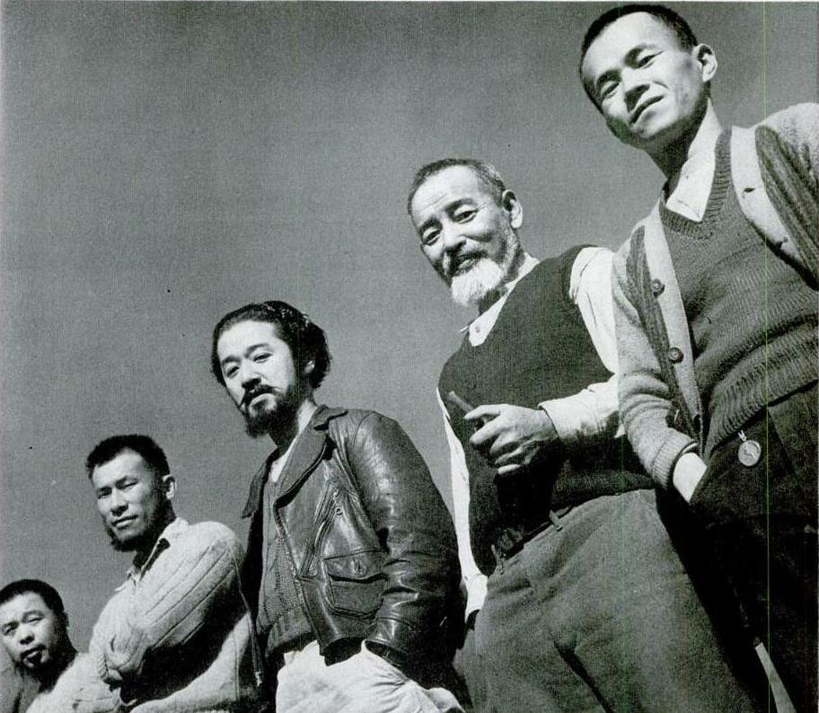
These five Japs are among 155 trouble makers imprisoned in the stockade within the Tule Lake Segregation Center. Here they are answering roll call.
TULE LAKE AT THIS SEGREGATION CENTER ARE 18,000
JAPANESE CONSIDERED DISLOYAL TO U.S.
The Japanese above, photographed behind a stockade within the Tule Lake Segregation Center at Newell, Calif., are trouble makers. Calling themselves "pressure boys," they are fantastically loyal to Japan. Along with some 150 other men in the stockade, they were ringleaders in the November riots which the U.S. Army, under the command of Lieut. Colonel Verne Austin, finally had to quell. By their strong-arm methods they are responsible for Tule Lake's reputation as worst of all civilian detention camps in U.S. [For more images, see Tule Lake Demonstration Photos.]
Most of the other 18,000 men, women and children of Japanese ancestry, now segregated at Tule Lake, are quiet, undemonstrative people. About 70% of them are American citizens by birth. All of the adults among them, however, are considered disloyal to the U.S. Either they have asked to be repatriated to Japan, or they have refused to take an oath of allegiance to the U.S., or they are suspected of being dangerous to the national security.
In March 1942, some 110,000 people of Japanese descent were moved out of their homes in strategic areas of the West Coast. Eventually they were settled in 10 relocation centers. There the loyal Japanese were separated from the disloyal. The loyal ones have the choice either of remaining in a relocation camp or of finding employment in some nonstrategic area. The disloyal ones have been sent to the segregation center at Tule Lake.
The November riots, in which some Americans were hurt, precipitated much heated discussion about the Tule Lake camp, and the center remains a political issue. LIFE last month sent Staff Photographer Carl Mydans to report on conditions there. He had himself just been repatriated from 16 months spent in Jap internment camps. At joint consent of War Relocation Authority, which has charge of the camp, and the Army, who guards it, he lived at Tule Lake for a week. His pictorial report, the first of its kind, follows.
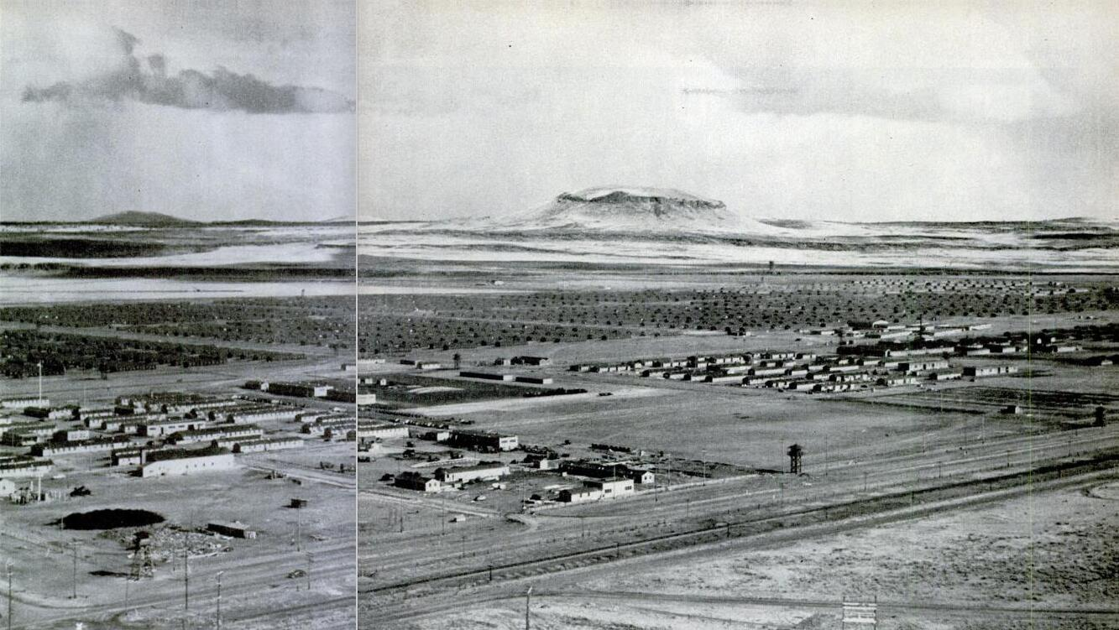
Center's 1,032 buildings lie on this flat plain, with Horse Mountain in the background. In the foreground are lookout towers, manned 24 hours a day by MP's, and the wire fence which surrounds the camp. The buildings at the left foreground are where Army troops live and those at the right foreground are the offices and barracks for the WRA. The new parade ground is in between. Behind it are buildings housing 18,000 Japanese. Even if the guards were removed, the Japanese probably would not try to escape. They are afraid of Tule Lake farmers.
CAMP IS ON DRAINED LAKE BOTTOM NEAR
SOME OF THE WORLD'S RICHEST FARMLAND

The area around Tule Lake in northern California, near the Oregon border, contains some of the world's richest farmland. Most of it is rockless bottom land, reclaimed by draining the lake. Originally it was homesteaded in 60-acre lots by World War I veterans. It is capable of grossing $1,000 an acre a year, and last month sold for $350 an acre.
The Tule Lake Segregation Center is located on the edge of this rich California farmland. Its 1,000 acres are not good for cultivation, but last year the War Relocation Authority leased 2,000 fertile adjoining acres for Japanese to farm. What happened was nearly tragic. The land was put to crops of potatoes, onions, carrots, beets, lettuce and peas. The Japanese diked the land, dug irrigation ditches and produced a rich crop on virgin soil.
Then at harvesttime trouble broke out in the center. A Japanese workman was killed when his truck was wrecked on the way to the farm area. Demonstrations were held. To get more control of camp government, the Japs proclaimed a policy of status quo. They would do no work. They would not farm the fields. As a result, to get the crop in before frost came, loyal Japanese from relocation centers had to be brought in to do the harvesting. Thousands of dollars worth of vegetables were almost lost.
Only in the last month has status quo at last been eliminated. This year, however, to take no chances, only 400 acres will be planted by the Japanese at Tule Lake.
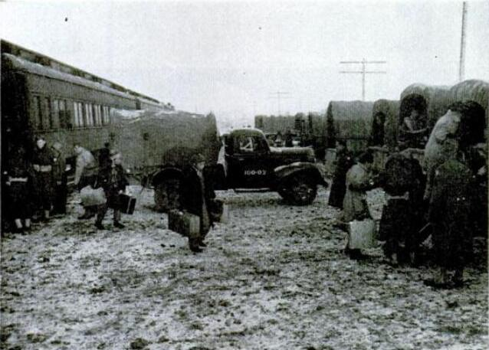
Disloyal Japanese arrive from Manzanar Relocation Center. There is no station at Tule Lake Center, but the train stops 150 yards from entrance. Army then drives newcomers into camp.

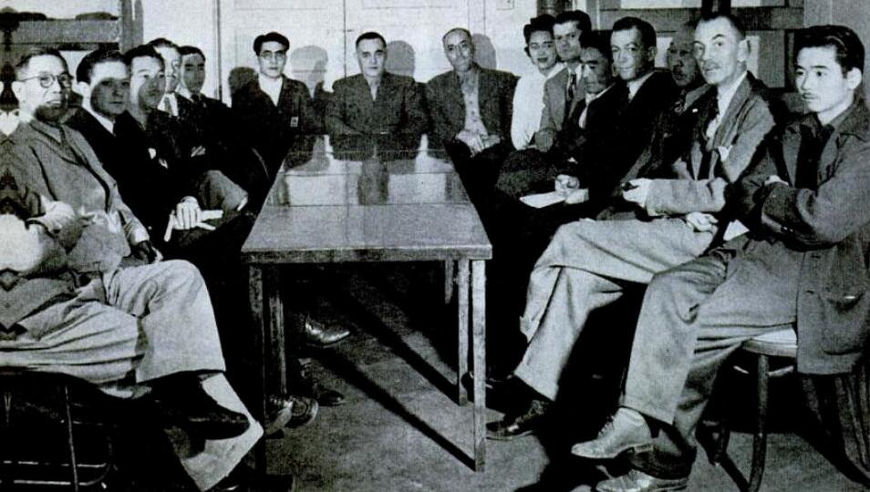
Representatives of the Japanese meet with WRA officials on camp problems. Center: Ray Best, WRA project manager.
After November riots "negotiating-committee" members, who had made demands on WRA, were put in stockade. A new "coordinating committee" was picked to represent Japanese.
This group, shown here, supported a return-to-work program.

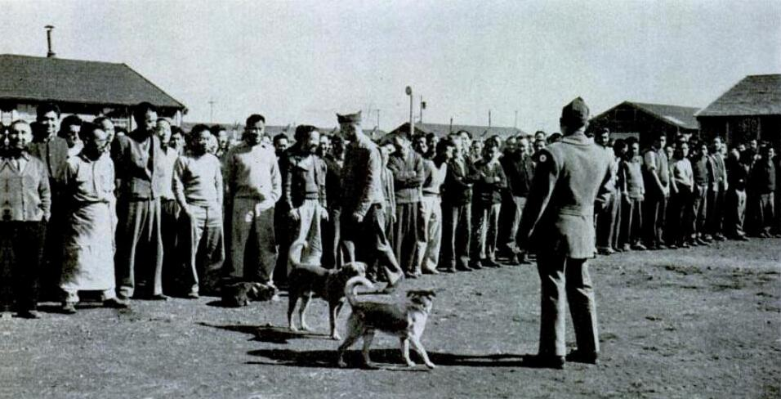
Roll call for "pressure boys" is taken by the Army.
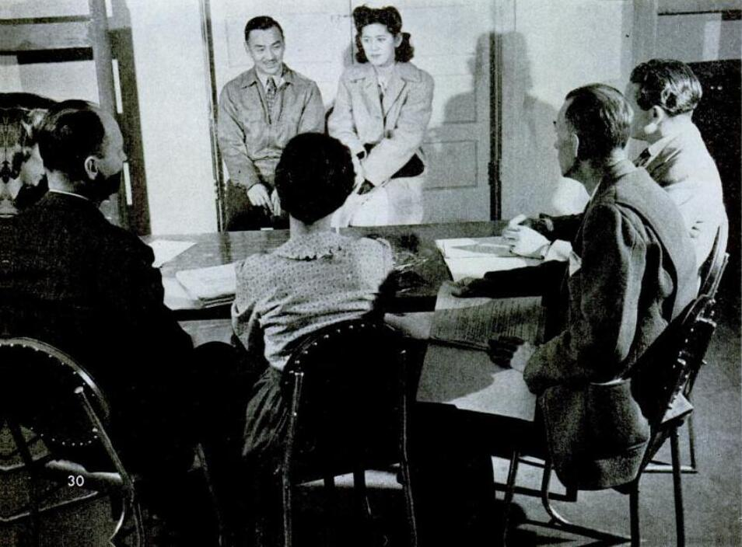
William and Roslyn Mayeda, have hearing before a WRA committee. They have been committed to repatriation by their parents. However, they now want to leave the camp. When they take oath of allegiance to U.S. and the FBI checks them, they will probably be relocated.

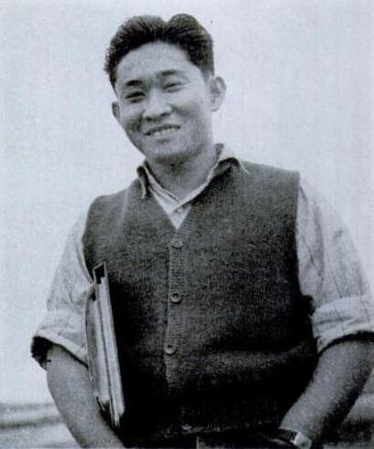

Yoshitaka Nakai, 26, has bought $8,000 in war bonds. When Nakai was picked up for relocation, his farm crop went bad. Angry, he refused to take allegiance oath. Now he wants to.
THEY HAVE EVERYTHING EXCEPT LIBERTY
The Japanese at Tule Lake have everything they need for happiness except the one thing they want most -- liberty. That they cannot have. They are prisoners, even though the War Relocation Authority tries to soften this fact by using the euphemistic name "Segregees." Because the problems which have arisen to plague the camp stem fundamentally from their loss of liberty, those problems can never really be solved. Their life cannot be made pleasant. It can only be made endurable.
The responsibility of WRA is to make life at Tule Lake endurable. This it has succeeded in doing, in the face of bitter criticism by part of the press, the public and the government. On the one side it has been accused of "Jap coddling." On the other it has been accused of depriving American citizens of their native rights.
In its accomplishment it has had the tactful help of the Army. Naturally both of them have made mistakes. At the time of the November riots they clamped an unwise censorship on the center, thus giving the wildest rumors the chance to spread across the country. But most important of all, they have avoided bloodshed.
These interned Japanese are not criminals. In peacetime they would be living normal civilian lives. But this is war and they are loyal to Japan, i.e., disloyal to the U.S. They must, of necessity, be put in a place where they cannot hurt the U.S.
But it is too easy to say that they are all disloyal and treat them all accordingly. Some 70% of them are American citizens. In almost every individual case there are conflicting loyalties. Young men and young women especially have disturbing sociological problems. They have perhaps been committed to repatriation by their parents. Yet they have been born and brought up here. What they know about Japan they have learned only from books and stories. They are accustomed to the American standard of living. They have gone to American schools and colleges.
Now suddenly they have been put in what seems to them a prison. Some of them are bitter. They feel as if they have no country at all. Carl Mydans talked to one such boy. The conversation:
Mydans: Why do you want to leave this country? You have never been to Japan.
Boy: Oh, I don't know. Japanese families always stick together. My mother and father want to go back.
Mydans: If you go to Japan, will you want to return here when the war is over?
Boy: No, I don't think I ever want to come back. The feeling will be too much against us.
Mydans: But you have never been to Japan. How do you know you'll want to stay there?
Boy: But I don't want to stay in Japan. None of us do.
Mydans: But then where will you go?
Boy: I don't know, really. Maybe Australia. We want to go where there are new frontiers. I think we'll find them in Australia. (Australia admits no Oriental immigrants. --ED.)
Other young Japanese are not so bitter. They have resolved their conflicting loyalties between family and the U.S. in favor of the U.S. To them WRA offers a chance for release from Tule Lake. If they are willing to take an oath of allegiance to the U.S. and are favorably checked by the FBI, they can be sent to one of the nine relocation centers. There they will have the opportunity to seek regular jobs in nonstrategic sections of the country.
But this method of release sometimes does not work. Recently a young Japanese workman and his wife were cleared for release into a "safe" area. At the last minute they refused to leave camp because of a false rumor that a Japanese family relocated on an Arkansas farm had been killed by an irate anti-Japanese mob.
In his report on Tule Lake photographer Mydans made an inevitable comparison between it and the prison camps he had seen at Manila and Shanghai. Said he:
"Americans interned under the Japanese have a certain ease of mind in knowing that as Americans they are considered enemies and nothing will be done for them. The Japs lay down a few all-inclusive regulations and the internees know that if they are broken, the entire camp will be severely punished. If a man escapes he will be shot.
"Over here we have the problem of American citizens being interned as aliens. There are political and sociological conflicts. The internees do not hate us, or the WRA, the way we hated the Japs and our guards.
"On the other hand internees over here are made physically comfortable out of all comparison to the comforts given us. The Japanese standard of living is lower than ours. In our camps we received as much food as the average Japanese civilian, yet it wasn't enough. The usual camp over there is an abandoned or bombed university building or warehouse. The place is dirty and empty. When internees are put into such a camp, they must bring their own bedding and beds, forage for most of their own food, build their own kitchens, carry their own garbage, build their own clinic, plan their own administration."
At Tule Lake all these things have been provided. Yet newspaper charges that the Japanese there are living in luxury are obviously exaggerated. By Japanese standards it is pretty luxurious but by American standards it is an ugly dreary way of life.
The task of the WRA is not easy. Nor will it get easier. The Japanese within the camp will keep up their agitation for better conditions. Current conditions must be maintained so that the Japanese Government itself will have no excuse for the bad situation in its own camps where Americans are imprisoned. The 18,000 Japs at Tule Lake are, in a sense, a form of insurance for the safety of some 10,000 American civilians still in the hands of the Japanese and as U.S. casualty lists grow longer and the war hatred grows more bitter, our treatment of these people will directly affect the treatment of our fellow Americans across the Pacific.
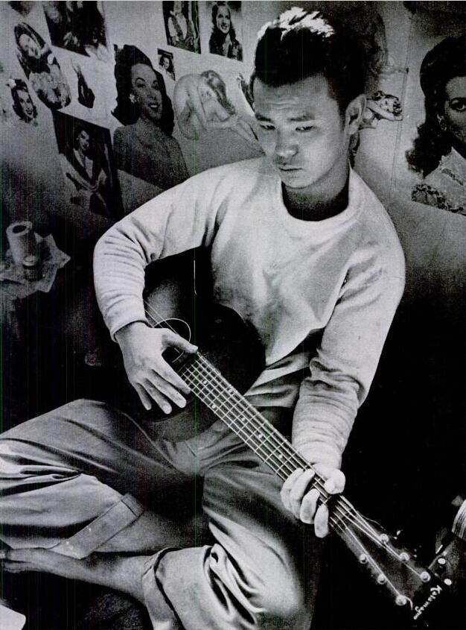
What it feels like to be a prisoner is shown in expression of this young Japanese "pressure boy," in stockade. He was singing Home on the Range when Mydans entered the stockade barracks. Reports Mydans: "He sang it like an American. There was no Japanese accent. He looked at me the same way I guess I looked at a Japanese official when he came to check on me at Camp Santo Tomás in Manila. At the back of my mind was the thought, 'Come on, get it over and get out. Leave me alone.'
This boy felt the same way. He was just waiting, killing time."

